ELECTRIC MOTOR TEMPERATURE PREDICTION USING MACHINE LEARNING

Alladi Johnpaul– Model Development & Deployment
D V Pravallika– Data Preprocessing & Analysis
Bodaballa Jaswanth– Frontend Development & Integration
Mahammad Adhil– Testing & Documentation

Project Overview
The purpose of this project is to develop a machine learning-based system that predicts the rotor temperature of an electric motor using sensor data. The system aims to enable predictive maintenance and prevent overheating-related failures in industrial environments.
• Features:
- Data preprocessing and feature scaling
- Multiple regression model comparison
- Decision Tree model selection
- Flask-based deployment
- Manual prediction module
- Sensor-based prediction module (future enhancement)
- Error handling and validation

Architecture
Frontend
The frontend is developed using:
- HTML
- CSS
It provides:
- Home page
- Manual input form
- Sensor module interface
- Prediction result display
The user enters motor parameters through the form, and the prediction result is displayed dynamically.
Backend
The backend is implemented using Flask (Python framework).
Responsibilities of the backend:
- Load trained model (model.save)
- Load scaler (transform.save)
- Accept user input via POST request
- Scale input using MinMaxScaler
- Predict rotor temperature using Decision Tree model
- Return prediction result to the user interface
Database
This project does not use a database. Instead:
- CSV file (measures_v2.csv) is used as dataset
- Pickle files are used for model storage
Future implementation may include cloud database integration for real-time data storage.

Setup Instructions
• Prerequisites
- Python 3.9
- pip
- VS Code (recommended)
- Required libraries:
  - numpy
  - pandas
  - scikit-learn
  - flask
  - matplotlib
  - seaborn

Installation
Step 1: Clone Repository
git clone https://github.com/Johnpaul-225/Electric-Motor-Temperature-Prediction.git
cd Electric-Motor-Temperature-Prediction

Step 2: Install Dependencies
pip install numpy pandas scikit-learn flask matplotlib seaborn

Step 3: Train Model
Open:
Notebook/Rotor_Temperature_Detection.ipynb
Run all cells to generate:
- model.save
- transform.save

Step 4: Copy Model Files
Copy:
model.save
transform.save
Paste into:
Flask/

Folder Structure
Electric-Motor-Temperature-Prediction/
│
├── Dataset/
│ └── measures_v2.csv
│
├── Notebook/
│ └── Rotor_Temperature_Detection.ipynb
│
├── Flask/
│ ├── app.py
│ ├── model.save
│ ├── transform.save
│ ├── templates/
│ │ ├── home.html
│ │ ├── manual_predict.html
│ │ └── sensor_predict.html
│ └── static/
│ └── style.css
│
└── README.md

Running the Application
Backend (Flask)
cd Flask
python app.py
Open browser:
http://127.0.0.1:5000
API Documentation
Home Route
GET /
Returns the home page.

Manual Page
GET /manual
Displays manual prediction form.

Predict Endpoint
POST /predict
Parameters:
- ambient
- coolant
- u_d
- u_q
- motor_speed
- i_d
- i_q
- stator_yoke
- stator_winding
Response:
Predicted rotor temperature displayed on UI.

Authentication
Authentication is not implemented in this academic project.
Future enhancements may include:
- Login system
- JWT-based authentication
- Role-based access control

User Interface
The user interface includes:
- Home page
- Manual input form
- Sensor module page
- Prediction output display

Testing
Testing included:
- Functional testing
- Input validation testing
- Model accuracy testing
- User Acceptance Testing (UAT)
All test cases passed successfully.
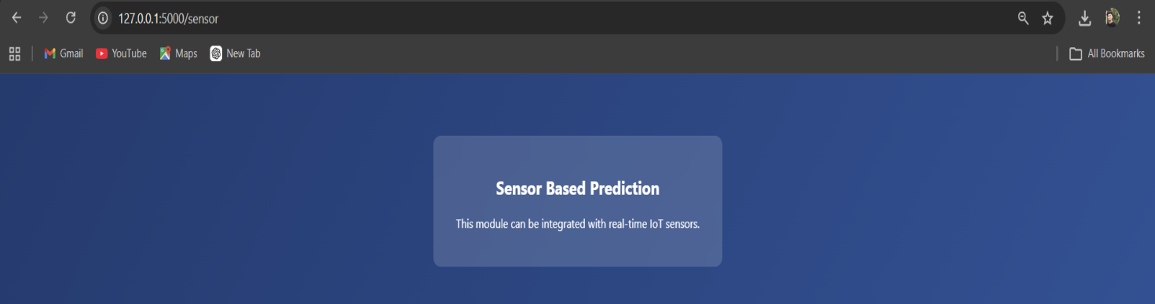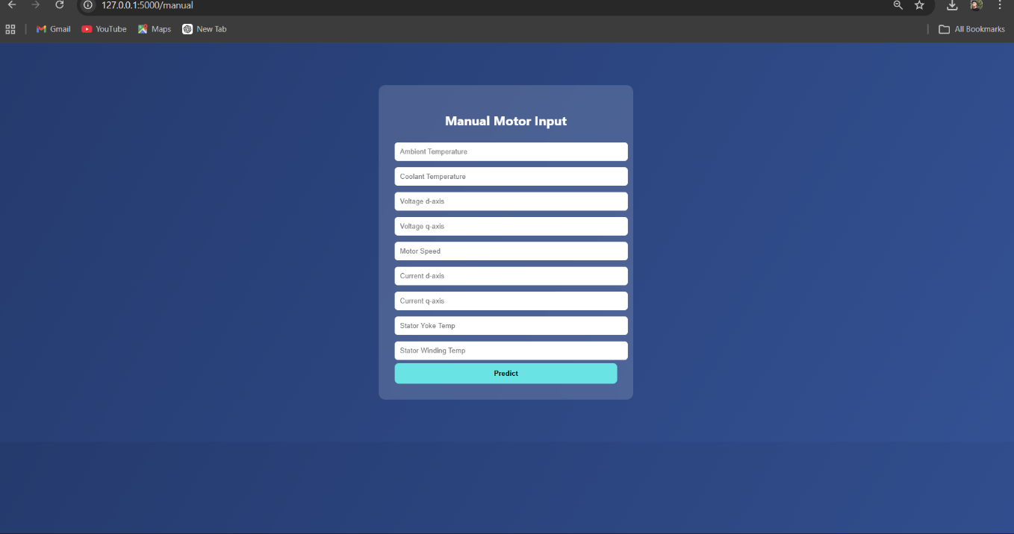
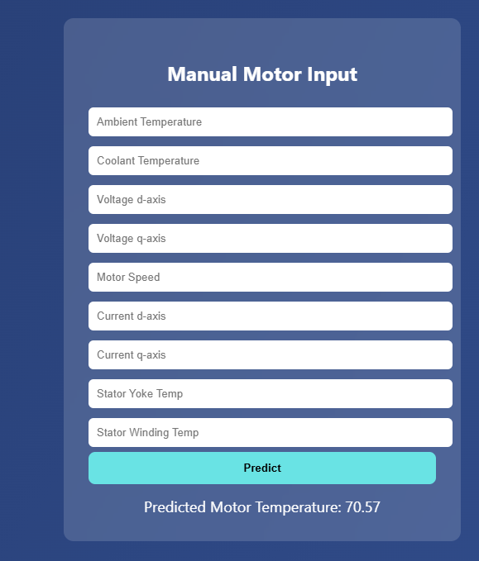

Known Issues
- Dataset not uploaded to GitHub due to file size limitation
- Sensor module currently conceptual
No major functional defects remain.

Future Enhancements
- Real-time IoT sensor integration
- Cloud deployment
- Mobile dashboard
- Deep learning model implementation
- Automated alert system

